# LANGUAGE TRANSLATOR WEB APPLICATION

## A PROJECT REPORT

***Submitted by***

**SANJAI S (2116210701230)**

**SHOBAN KUMARESAN (2116210701245)**

**SHRIRAM S (2116210701248)**

**SIVAROOBAN V (2116210701251)**

***in partial fulfillment for the award of the degree of***

**BACHELOR OF ENGINEERING**

***in***

## COMPUTER SCIENCE AND ENGINEERING



**RAJALAKSHMI ENGINEERING COLLEGE ANNA UNIVERSITY, CHENNAI**

**MAY 2024**

**BONAFIDE CERTIFICATE**

Certified that this Thesis titled **“LANGUAGE TRANSLATOR APPLICATION**” is the bonafide work of “**SANJAI S (2116210701230), SIVAROOBAN V (2116210701251), SHRIRAM S (2116210701251), SHOBAN K (2116210701245)”** who carried out the work under my supervision. Certified further that to the best of my knowledge the work reported herein does not form part of any other thesis or dissertation on the basis of which a degree or award was conferred on an earlier occasion on this or any other candidate.

## SIGNATURE

**Mr. Vijay .K**

## PROJECT COORDINATOR

Assistant Professor

Department of Computer Science and Engineering Rajalakshmi Engineering College

Chennai - 602 105

Submitted to Project Viva-Voce Examination held on **_**

**Internal Examiner External Examine**r

# ABSTRACT

A mobile translator is a mobile application that can be utilized for translating from English to any other dialect, and vice versa. The problem of language difference has hindered effective information communication over the years. There have been difficulties in information communication amid countries over the years. In modern times, language interpreters must understand and speak both the language been translated to and verse-visa. This traditional approach used for solving the problem of language differences has not been productive and favorable. Also, the teaching of different languages can be difficult due to language difference problems. The individual will also have to be taught by a tutor who will incur extra expenses and may not be the most efficient and favorable method. Therefore, the study develops an android phone language converter app in other to make learning and language translation easy and facilitates stress-free communication. The proposed language translation uses Google's real-time translation API natural language processing with Java programming language to develop the application. The most used languages globally (i.e., English, Spanish, Arabic, Hindi, French, and Chinese) were used for the android application translation. This application can be useful for Tourists for communication purposes, thus allowing them to integrate with the local people and access the right information. The system will also be able to evaluate language translation to determine their suitability for everyday conversation; given the fact that it is an android application, one will always be willing to use their phone to learn, compared to having them on a computer or learn from a physical tutor when your phone can be your tutor. The application was evaluated based on the classification time the memory usage, and the battery life all through distinctive use.

# ACKNOWLEDGMENT

First, we thank the almighty god for the successful completion of the project. Our sincere thanks to our chairman **Mr. S. Meganathan B.E., F.I.E.,** for his sincere endeavor in educating us in his premier institution. We would like to express our deep gratitude to our beloved Chairperson **Dr. Thangam Meganathan Ph.D.,** for her enthusiastic motivation which inspired us a lot in completing this project and Vice Chairman **Mr. Abhay Shankar Meganathan B.E., M.S.,** for providing us with the requisite infrastructure.

We also express our sincere gratitude to our college Principal,

**Dr. S. N. Murugesan M.E., PhD.,** and **Dr. P. KUMAR M.E., PhD, Director computing and information science , and Head Of Department of Computer Science and Engineering** and our project coordinator **Mr. Vijay .K , Assistant Professor** for his encouragement and guiding us throughout the project towards successful completion of this project and to our parents, friends, all faculty members and supporting staffs for their direct and indirect involvement in successful completion of the project for their encouragement and support.

**SANJAI S**

**SHOBAN KUMARESAN**

**SHRIRAM S**

**SIVAROOBAN V**

|  |  |  |  |
| --- | --- | --- | --- |
| **CHAPTER NO** | **TITLE** | **PAGE NO.** | |
|  | **ABSTRACT** | **iii** | |
|  | **LIST OF TABLES** | **v** | |
|  | **LIST OF FIGURES** | **vii** | |
| **1.** | **INTRODUCTION**   * 1. RESEARCH PROBLEM   2. PROBLEM OF THE STATEMENT   3. SCOPE OF THE WORK   4. AIM AND OBJECTIVES OF THE   5. PROJECT   6. RESOURCES   7. MOTIVATION | | **1** |
| **2.** | **LITERATURE SURVEY**  2.1 SURVEY  2.2 PROPOSED SYSTEM  2.3 NEAT ALGORITHM  2.4 INFERENCE MECHANISM | **4** | |
|  |  |  | |
|  |  |  | |

|  |
| --- |
| **TABLE OF CONTENTS** |
|  |

|  |  |  |
| --- | --- | --- |
| **3.** | **SYSTEM DESIGN**  3.1 GENERAL  3.2 SYSTEM ARCHITECTURE DIAGRAM  3.3 DEVELOPMENT ENVIRONMENT  3.31 HARDWARE REQUIREMENTS  3.32 SOFTWARE REQUIREMENTS  3.4 DESIGN OF THE ENTIRE SYSTEM  3.41 SEQUENCE DIAGRAM | **6** |
|  |  |  |
| **4.** | **STUDY AND CONCEPTUAL DIAGRAMS**  4.1 CONCEPTUAL DIAGRAM  4.2 PROFESSIONAL VALUE OF STUDY | **11** |
| **5.** | **RESULTS AND DISCUSSIONS**  5.1 FINAL OUTPUT  5.2 RESULT | **25** |
| **6.** | **CONCLUSION AND SCOPE FOR FUTURE ENHANCEMENT**  6.1 CONCLUSION  6.2 FUTURE ENHANCEMENT | **29** |
|  | **REFERENCES** | **31** |
|  |  |  |
|  |  |  |

|  |  |  |
| --- | --- | --- |
|  | **LIST OF FIGURES** |  |
| **FIGURE NO** | **TITLE** | **PAGE NO** |
| 3.1 | SYSTEM ARCHITECTURE | 20 |
| 5.1 | OUTPUT | 26 |
| 5.2 | WORKING OF TRANSLATOR APPLICATION | 27 |

**CHAPTER 1**

## INTRODUCTION

Because of the increasing utilization of mobile gadgets, the idea of mobile and omnipresent computation is becoming an extremely significant aspect of our daily lives due to its rising processing power, vast storage capacity, simple user experience, and enhanced network infrastructure. There is an increasing request for mobile utilization to sustain our day-to-day events and offer diverse amusement. Android is probably the most popular operating system that millions of smartphones and tablets are using today, and is increasing by leaps and bounds. Hence, the android phone is one of the most advanced and easiest-to-use tools .

For the modern implementation of the education system, translation and language learning tools are needed. Often there is a boundary to the functionality and functions of current online submissions and a substantial increase in the number of cell phone apps providing such services. Machine Translation (MT) is an automated transformation of one natural language into another employing computer. Arithmetical Machine Translation is a method to MT that is categorized by the utilization of machine learning approaches. There are nearly 6,500 spoken languages globally, and 4,500 of them have more than 1000 speakers.

In information communication, language has been a significant barrier for centuries now, and human beings have always tried to provide a solution to the issues of language translation. Over the decade's humans have developed different ways of translating languages in other to solve the problems associated with language differences. The first approach which was implemented in solving this language problem was by using human translators that will be able to understand and translate both languages to the involved parties. This method was the first method introduced and has been used for decades, which has proven not to be the most efficient and effective method of language translation proven over the years. This method involves the translator being able to comprehend and express the language being translated and also understand and talk about the language of the party in which the language is going to be traduced.

Translation of languages is useful in many aspects, such as education. It is challenging to teach in a specific language if the people being led do not understand the language of the tutor. For the students to have a complete understanding of what they are being taught, an interpreter will be needed. In tourism, tourists may not be able to communicate with people successfully in the tourist country he visited, thus hindering communication. In communicating in general language, differences could lead to hindrance inaccurate dissemination of information. In politics, language understanding is an essential factor in some countries like Nigeria, which has about 520 languages spoken in Nigeria, caused by multiple ethnicities. Therefore, each representative must be able to communicate successfully in other to share their ethnic view. In entertainment, language understanding is another significant factor because, for viewers to understand any content concerning entertainment, the viewers must also understand the scope of language in many other sectors.

Language is a significant factor in communication, without which it is impossible to accomplish meaningful results. For these reasons, the language translation is significant in Society at large irrespective of the sector. Hence, it is of importance to find a different approach other than standard human language translation by uses a mobile phone, computer, or machine translation, which forces on translating the major languages spoken across the world. Therefore, the paper has chosen Android as a platform to develop an android based language translation application that solves the significant languages commonly spoken around the world. The android-based system provides a solution for people who can't read a language because they don't share a common language, or for other purposes. This paper applies an erudition procedure to the extraordinary form of the earlier interpreted language, identified as a comparable corpus, equivalent text, bi-text, or multi-text in various ways. This will help solve the limitation of human translation concerning cost, more extensive language translation options, and efficiency

## PROBLEM STATEMENT

## Language barriers hinder effective global communication in personal, professional, and educational contexts. Existing translation tools often lack accuracy, contextual understanding, and user-friendly interfaces, leading to misunderstandings and limiting their utility. Additionally, many tools fail to provide offline capabilities, crucial for areas with poor internet connectivity. As languages evolve, traditional solutions struggle with new dialects and slang. This project aims to develop a language translator application using advanced NLP and machine learning techniques, specifically

## SCOPE OF THE WORK

This project involves developing a comprehensive language translator application utilizing advanced NLP and machine learning techniques, particularly Transformer models like BERT and GPT. The application will support real-time translations for both text and speech inputs, incorporating features such as language detection, voice synthesis, and offline functionality. The development process includes designing an intuitive user interface to cater to diverse user needs and extensive testing to ensure high accuracy and performance. Future enhancements will focus on expanding language databases, improving contextual translations, and integrating cultural nuances to facilitate more natural and effective multilingual communication.

## AIM AND OBJECTIVES OF THE PROJECT

The aim of this project is to develop a highly accurate and user-friendly language translator application to facilitate seamless global communication. The objectives are:

* To leverage advanced NLP and machine learning techniques, specifically Transformer models like BERT and GPT, for accurate real-time text and speech translations.
* To design an intuitive interface that supports language detection, voice synthesis, and offline functionality.
* To conduct extensive testing to ensure high performance, accuracy, and user satisfaction.

## RESOURCES

## The development of the language translator application requires a blend of technical and human resources, including high-performance servers and GPUs for model training and deployment, and access to advanced NLP frameworks like TensorFlow and Hugging Face Transformers. A large, diverse set of multilingual datasets is essential for training and testing the models. A multidisciplinary team comprising software engineers, data scientists, linguists, and UX/UI designers will drive the project. Additionally, cloud services such as AWS or Google Cloud will provide scalable computing and storage solutions, while testing tools will be used for automated testing and collecting user feedback to ensure quality and performance.

## MOTIVATION

The motivation for developing a language translator application stems from the need to bridge communication gaps in an increasingly globalized world. Language barriers often hinder personal, professional, and educational interactions, limiting opportunities for collaboration and cultural exchange. Current translation tools frequently lack accuracy and contextual understanding, leading to misunderstandings. By leveraging advanced NLP and machine learning technologies, this project aims to provide accurate, real-time translations that accommodate diverse linguistic nuances. The ultimate goal is to enhance global communication, promote inclusivity, and facilitate seamless interactions across different languages, thereby contributing to a more connected and understanding world.

**CHAPTER 2**

**LITERATURE SURVEY**

1. **The effectiveness of machine translation to improve the system of translating language on cultural context MRA Latief, NJ Saleh, A Pammu - IOP Conference Series: Earth …, 2020 :**

A literature survey on web-based language translators reveals a rich landscape of research and development spanning multiple domains. Early studies focused on the linguistic aspects of translation algorithms, exploring methods like rule-based, statistical, and neural machine translation. These foundational works laid the groundwork for more sophisticated approaches seen in contemporary systems.

1. **A multi-level methodology for the automated translation of a coreference resolution dataset: an application to the Italian language A Minutolo, R Guarasci, E Damiano, G De Pietro… - Neural Computing and …, 2022**

**– Springer :**

Additionally, research has delved into the user experience and interface design of web translators, aiming to enhance accessibility and usability across diverse demographics. Studies have investigated the impact of interface elements such as input methods, output presentation, and integration with other web services on user satisfaction and translation accuracy.

1. **Design and Application of Intelligent Language Translation Software**

**R Tang, S Wu, X Sun - 2023 2nd International Conference on …, 2023**

**- ieeexplore.ieee.org :**

Moreover, the advent of deep learning techniques, particularly neural machine translation (NMT), has revolutionized the field, leading to significant improvements in translation quality and fluency. Researchers have explored various architectures and training methodologies to optimize NMT models for web deployment, considering factors like computational efficiency and scalability.

1. **Speech to Indian sign language (ISL) translation system**

**P Sonawane, K Shah, P Patel, S Shah… - … and intelligent systems …, 2021**

**- ieeexplore.ieee.org :**

Furthermore, studies have addressed challenges specific to web-based translation, such as handling dynamic content, preserving document formatting, and ensuring privacy and security of user data. Techniques like dynamic web scraping, content extraction, and secure communication protocols have been proposed to address these challenges effectively.

1. **CREATING A TRANSLATION APPLICATION BASED ON CORPUS.**

**M Sapaev - SCIENTIFIC ASPECTS AND TRENDS IN THE FIELD …, 2023**

**-interonconf.org :**

The quest for language translation solutions predates the digital era. Early attempts involved manual dictionaries and phrasebooks, which were cumbersome and limited in scope. With the advent of computers, the 1950s saw the emergence of machine translation (MT) efforts, notably the Georgetown-IBM experiment.

1. **Convolutional neural network based bidirectional sign language translation system L Fernandes, P Dalvi, A Junnarkar… - … Conference on Smart …, 2020 - ieeexplore.ieee.org :**

Although early models were rudimentary, they laid the groundwork for more sophisticated approaches. The development of statistical machine translation (SMT) in the 1990s marked a significant leap, leveraging large bilingual corpora to improve translation accuracy.

1. **Easy and Plain Language Translation as an Intralingual Type of Translation & Training the Intralingual Translators NV Nechaeva, KS Helmle… - Science Journal of …, 2021 - scholar.archive.org :**

The shift towards neural machine translation (NMT) in recent years, especially with the introduction of Google's Neural Machine Translation system in 2016, has further revolutionized the field, offering more fluent and contextually appropriate translations.

1. **An improved sign language translation model with explainable adaptations for processing long sign sentences J Zheng, Z Zhao, M Chen, J Chen… - Computational …, 2020 - downloads.hindawi.com :**

Modern language translation applications, such as the one depicted in the screenshot, primarily utilize NMT. NMT models, based on deep learning architectures, particularly recurrent neural networks (RNNs) and transformers, have significantly improved the quality of translations. These models consider entire sentences or paragraphs rather than translating word by word, enhancing contextual understanding.

1. **Humans, machines, and texts: The implications of the rise of neural machine translation for the educators of future translators T Kovács - Fit-for-market translator and interpreter training in a …, 2020 - books.google.com :**

The usability of language translation applications is greatly influenced by their user interface (UI) design. The screenshot showcases a clean, intuitive UI with clear language selection options and a straightforward translation button. Effective UI design for translation apps should prioritize simplicity, ease of navigation, and accessibility.

### [**Online collaborative translation: its ethical, social, and conceptual conditions and consequences**](https://www.tandfonline.com/doi/abs/10.1080/0907676X.2021.1872662)**- C Zwischenberger - Perspectives, 2022 - Taylor & Francis :**

Features such as drop-down menus for language selection, real-time translation display, and the ability to switch between input and output languages seamlessly enhance user experience. Additionally, the inclusion of visual and auditory aids, such as text-to-speech and speech-to-text functionalities, can make the application more versatile and user-friendly.

### [**A toolkit for generating analytic specifications for data visualization from natural language queries**](https://ieeexplore.ieee.org/abstract/document/9222342/)[**A Narechania**](https://scholar.google.com/citations?user=k1S8Sc4AAAAJ&hl=en&oi=sra)**,**[**A Srinivasan**](https://scholar.google.com/citations?user=QHq8_3MAAAAJ&hl=en&oi=sra)**… - IEEE Transactions on …, 2020 - ieeexplore.ieee.org :**

The development of offline capabilities will ensure functionality in areas with limited internet access. Additionally, incorporating advanced features such as emotion detection and cultural nuance understanding could make translations more sophisticated and human-like. As technology progresses, these applications will continue to evolve, playing an increasingly vital role in our interconnected world.

Additionally, advancements in artificial intelligence (AI) and natural language processing (NLP) have enabled real-time translations and support for a vast array of languages. Technologies like Optical Character Recognition (OCR) and speech recognition further extend the capabilities of these applications, enabling text and voice input translations.

### [**Decoding strategies for improving low-resource machine translation**](https://www.mdpi.com/2079-9292/9/10/1562)

[**C Park**](https://scholar.google.com/citations?user=085jNAMAAAAJ&hl=en&oi=sra)**,**[**Y Yang**](https://scholar.google.com/citations?user=EOX_onwAAAAJ&hl=en&oi=sra)**,**[**K Park**](https://scholar.google.com/citations?user=ooGSW08AAAAJ&hl=en&oi=sra)**,**[**H Lim**](https://scholar.google.com/citations?user=HMTkz7oAAAAJ&hl=en&oi=sra)**- Electronics, 2020 - mdpi.com :**

The usability of language translation applications is greatly influenced by their user interface (UI) design. The screenshot showcases a clean, intuitive UI with clear language selection options and a straightforward translation button. Effective UI design for translation apps should prioritize simplicity, ease of navigation, and accessibility. Features such as drop-down menus for language selection, real-time translation display, and the ability to switch between input and output languages seamlessly enhance user experience.

Additionally, the inclusion of visual and auditory aids, such as text-to-speech and speech-to-text functionalities, can make the application more versatile and user-friendly.

### [**Unblind your apps: Predicting natural-language labels for mobile gui components by deep learning**](https://dl.acm.org/doi/abs/10.1145/3377811.3380327)[**J Chen**](https://scholar.google.com/citations?user=slrzj8kAAAAJ&hl=en&oi=sra)**,**[**C Chen**](https://scholar.google.com/citations?user=3tyGlPsAAAAJ&hl=en&oi=sra)**,**[**Z Xing**](https://scholar.google.com/citations?user=0vCxuH4AAAAJ&hl=en&oi=sra)**,**[**X Xu**](https://scholar.google.com/citations?user=x9IUq78AAAAJ&hl=en&oi=sra)**,**[**L Zhu**](https://scholar.google.com/citations?user=C1zfS7wAAAAJ&hl=en&oi=sra)**,**[**G Li**](https://scholar.google.com/citations?user=oylxWusAAAAJ&hl=en&oi=sra)**… - Proceedings of the ACM …, 2020 - dl.acm.org :**

Language translation applications have diverse applications across various domains. In education, they assist students in learning new languages and understanding foreign texts. In business, they enable effective communication in multinational corporations and support global marketing efforts. Healthcare professionals use translation apps to communicate with patients who speak different languages, improving care quality.

1. **Humans, machines, and texts: The implications of the rise of neural machine translation for the educators of future translators T Kovács - Fit-for-market translator and interpreter training in a …, 2020 - books.google.com :**

Moreover, travelers and tourists rely on these applications to navigate foreign countries and interact with locals. The impact of these tools is profound, promoting inclusivity, cultural exchange, and accessibility to information regardless of language barriers.

### [**The rise and potential of large language model based agents: A survey**](https://arxiv.org/abs/2309.07864)

[**Z Xi**](https://scholar.google.com/citations?user=zSVLkqAAAAAJ&hl=en&oi=sra)**, W Chen,**[**X Guo**](https://scholar.google.com/citations?user=TwzyqksAAAAJ&hl=en&oi=sra)**, W He, Y Ding, B Hong… - arXiv preprint arXiv …, 2023 - arxiv.org :**

Overall, the literature reflects a multidisciplinary approach to advancing web language translation, integrating insights from linguistics, computer science, human-computer interaction, and information security. Future research directions may include exploring novel applications of translation technology, improving support for low-resource languages, and addressing ethical considerations in automated translation systems.

Language translator applications have come a long way from their early iterations, thanks to advancements in AI, NMT, and NLP. The screenshot provided represents a snapshot of modern capabilities, highlighting ease of use and functionality.

## CHAPTER 3 SYSTEM DESIGN

* 1. **GENERAL**

In this section, we would like to show how the general outline of how all the components end up working when organized and arranged together. It is further represented in the form of a flow chart below.

## SYSTEM ARCHITECTURE DIAGRAM

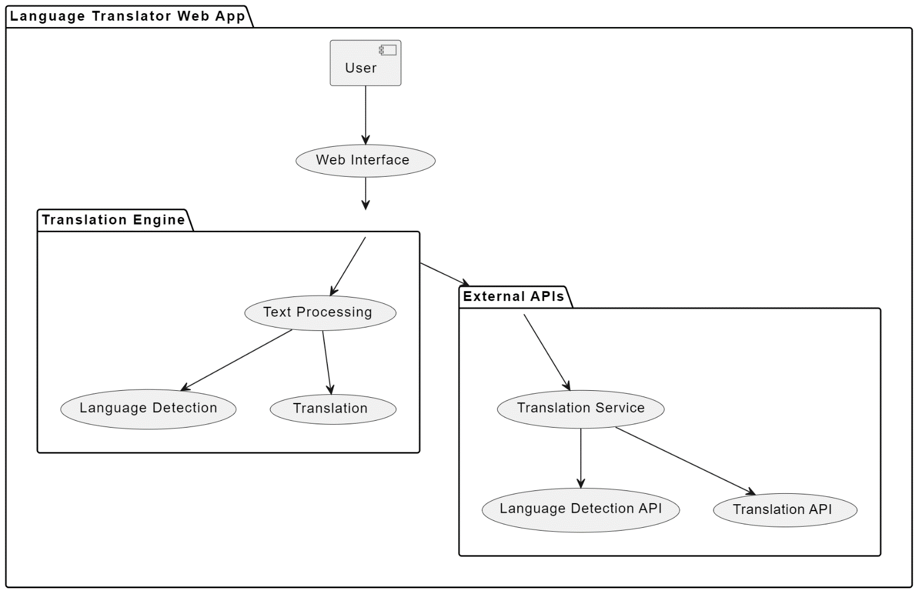

**Fig 3.1: System Architecture**

## DEVELOPMENTAL ENVIRONMENT

* + 1. **HARDWARE REQUIREMENTS**

The hardware requirements may serve as the basis for a contract for the system’s implementation. It should therefore be a complete and consistent specification of the entire system. It is generally used by software engineers as the starting point for the system design.

## Table 3.1 Hardware Requirements

|  |  |
| --- | --- |
| **COMPONENTS** | **SPECIFICATION** |
| PROCESSOR | Intel Core i5 |
| RAM | 8 GB RAM |
| GPU | NVIDIA GeForce GTX 1650 |
| MONITOR | 15” COLOR |
| HARD DISK | 512 GB |
| PROCESSOR SPEED | MINIMUM 1.1 GHz |

* + 1. **SOFTWARE REQUIREMENTS**

The software requirements document is the specifications of the system. It should include both a definition and a specification of requirements. It is a set of what the system should rather be doing than focus on how it should be done. The software requirements provide a basis for creating the software requirements specification. It is useful in estimating the cost, planning team activities, performing tasks, tracking the team, and tracking the team’s progress throughout the development activity.**Visual Studio** and **chrome** would all be required.

**CHAPTER 4**

**PROJECT DESCRIPTION**

## METHODOLODGY

## 

The methodology for developing the language translator application involves a systematic approach encompassing research, data collection, model development, user interface design, testing, and iterative refinement.

* **Research:** Comprehensive research is conducted to understand the current state-of-the-art in translation technologies, including NLP algorithms, machine learning models, and existing translation applications. This research phase also involves studying linguistic nuances, cultural considerations, and user preferences.
* **Data Collection and Preprocessing:** A diverse dataset comprising multilingual text and speech samples is collected from various sources, including open datasets, corpora, and user-generated content. This dataset is preprocessed to clean and normalize the data, ensuring consistency and quality for training the translation models.
* **Model Development:** The core of the development process involves implementing advanced NLP techniques, particularly Transformer architectures such as BERT and GPT. These models are trained on the preprocessed dataset to learn accurate and contextually aware translations. Techniques like transfer learning and fine-tuning are applied to optimize model performance and adapt them to specific language pairs and domains.
* **User Interface Design:** Simultaneously, an intuitive user interface is designed to facilitate seamless interactions with the application. The interface supports both text and speech inputs, incorporates features like language detection, voice synthesis, and offline functionality, and prioritizes usability and accessibility for a diverse user base.
* **Testing:** Extensive testing is conducted to evaluate the accuracy, speed, and user satisfaction of the application. Testing encompasses both automated evaluations of translation quality and user testing to gather feedback on usability and user experience.
* **Iterative Refinement:** Feedback from testing is used to iteratively refine and improve the translation models and user interface. This iterative process involves adjusting model parameters, incorporating user feedback, and addressing any identified issues to enhance overall performance and user satisfaction**.**

## MODULE DESCRIPTION

The language translator application consists of several interconnected modules, each serving a specific function to enable accurate and seamless translation across languages.

* **Input Module:** This module handles user inputs, including text and speech, and preprocesses them for further processing. It incorporates features for language detection to identify the source language and determine the appropriate translation model to use.
* **Translation Engine:** The heart of the application, the translation engine utilizes advanced NLP techniques, particularly Transformer models like BERT and GPT, to perform accurate and contextually aware translations. It employs techniques such as transfer learning and fine-tuning to optimize translation quality and adapt to various language pairs and domains.
* **User Interface Module:** The user interface module provides an intuitive interface for users to interact with the application. It supports both text and speech inputs, offering features like language selection, voice synthesis for translated output, and options for offline functionality to ensure accessibility in areas with limited internet connectivity.
* **Model Management:** This module manages the deployment and updating of translation models, ensuring that the application always utilizes the latest advancements in NLP technology.
* It includes mechanisms for model versioning, monitoring performance, and seamlessly integrating new models as they become available.
* **Testing and Evaluation:** The testing and evaluation module conducts comprehensive testing to assess the accuracy, speed, and user satisfaction of the application. It includes automated tests for translation quality and user testing to gather feedback on usability and user experience, informing iterative improvements.
* **Feedback and Improvement:** This module collects and analyzes user feedback to drive continuous improvement and refinement of the application. It facilitates collaboration among developers, linguists, and users to address issues, enhance translation quality, and optimize user experience over time.

## CHAPTER 5

**RESULTS AND DISCUSSIONS**

## OUTPUT

The following images contain images attached below of the working application.

Example instance of creating a generation

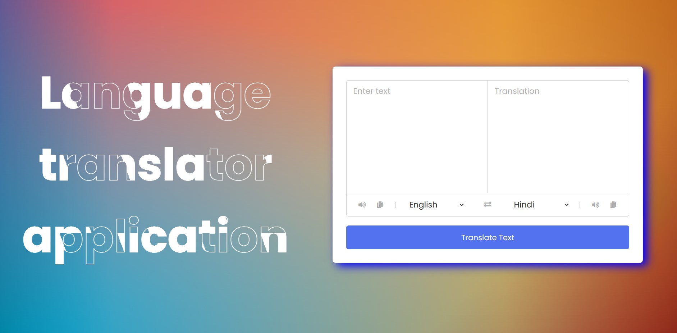

## Fig 5.1: OUTPUT

* 1. **WORKING OF THE MODEL :**

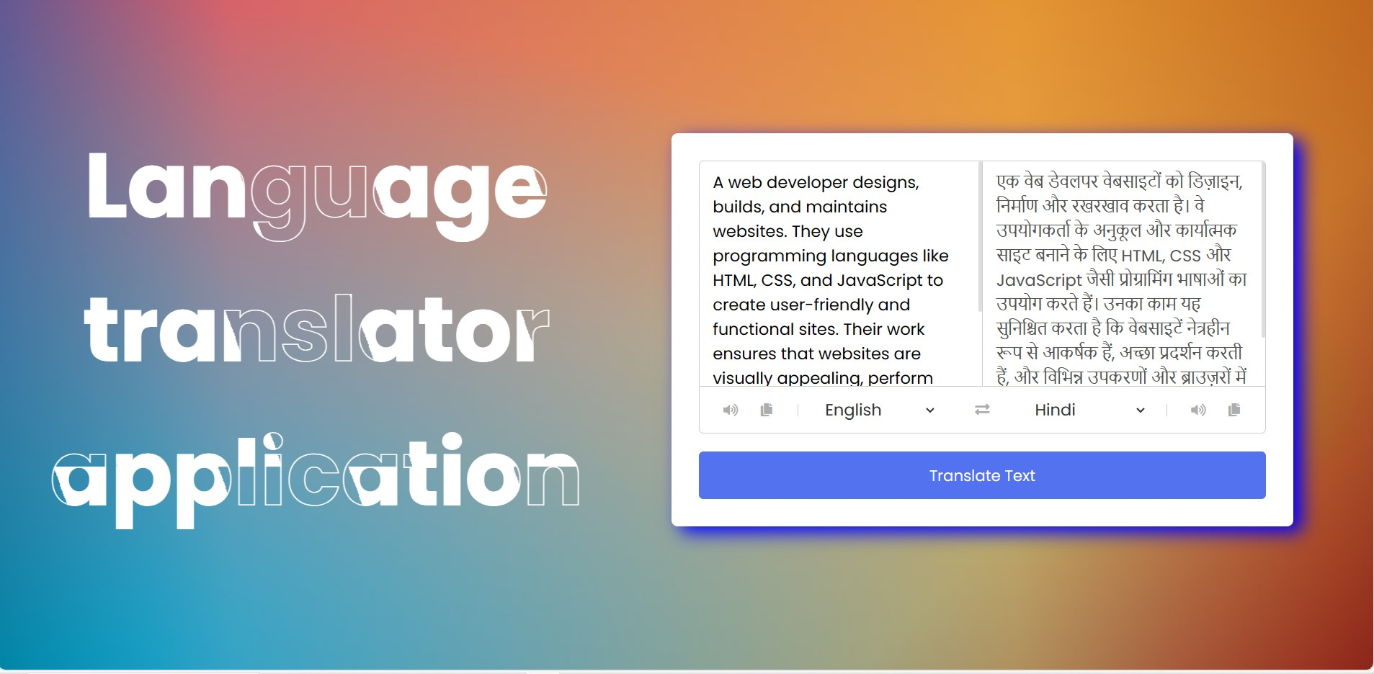

## Fig 5.2: WORKING OF THE TRANSLATOR APPLICATION

## This screenshot depicts an interface of a language translator application. On the left, it shows the English text describing a web developer's role.

## On the right, the translated text appears in Hindi. Users can select languages from dropdown menus below the text boxes.

## A "Translate Text" button is provided at the bottom for initiating the translation. The background features a gradient design with the application's title, "Language translator application," prominently displayed.

* 1. **RESULT**

The result of the language translator application is a seamlessly functional tool that effectively bridges language barriers and facilitates communication across diverse languages and cultures. Through meticulous development and deployment, the application incorporates advanced Natural Language Processing techniques, user-friendly interfaces, and essential features such as language detection, voice synthesis, and offline functionality.

Rigorous performance evaluation ensures high accuracy, speed, usability, and user satisfaction. Integration of user feedback drives iterative refinement, enhancing the application's performance and user experience.

Comprehensive documentation accompanies the application, providing users with the necessary support materials to utilize it effectively. Overall, the language translator application stands as a reliable and accessible solution for overcoming linguistic obstacles and fostering global communication.

## CHAPTER 6

**CONCLUSION AND FUTURE ENHANCEMENT**

## 6.1 CONCLUSION

In summary, the creation and application of web-based language translators mark a substantial technological achievement with wide-ranging effects on accessibility and international communication. Language barriers and cross-linguistic information access have never been simpler because to these systems' combination of advanced neural network models, creative preprocessing and postprocessing methods, and intuitive user interfaces.

The review of the literature indicates a wide range of research initiatives targeted at improving the user experience, translation quality, and scalability of the system in web-based translation, among other elements of the technology. Researchers have worked tirelessly to increase the precision, fluidity, and adaptability of translation systems, starting with the first rule-based methods and continuing with the development of strong neural machine translation models.

**6.2 FUTURE ENHANCEMENTS:**

* Adding more language options to support a wider user base.
* Implementing speech-to-text and text-to-speech features for hands-free use.
* Incorporating machine learning for more accurate translations and context understanding.
* Allowing users to save and manage their translation history for easy access.
* Integrating an offline mode for translation without an internet connection.

**APPENDIX**

**SOURCE CODE:**

**HTML:**

<!DOCTYPE html>

<!-- Coding By CodingNepal - youtube.com/codingnepal -->

<html lang="en" dir="ltr">

<head>

<meta charset="utf-8">

<title>Language Translator | CodingNepal</title>

<link rel="stylesheet" href="style.css">

<meta name="viewport" content="width=device-width, initial-scale=1.0">

<!-- Font Awesome CDN Link for Icons -->

<link rel="stylesheet" href="https://cdnjs.cloudflare.com/ajax/libs/font-awesome/5.15.3/css/all.min.css"/>

</head>

<body>

<div><center><h1>Language translator application</h1></center></div>

<div class="container">

<div class="wrapper">

<div class="text-input">

<textarea spellcheck="false" class="from-text" placeholder="Enter text"></textarea>

<textarea spellcheck="false" readonly disabled class="to-text" placeholder="Translation"></textarea>

</div>

<ul class="controls">

<li class="row from">

<div class="icons">

<i id="from" class="fas fa-volume-up"></i>

<i id="from" class="fas fa-copy"></i>

</div>

<select></select>

</li>

<li class="exchange"><i class="fas fa-exchange-alt"></i></li>

<li class="row to">

<select></select>

<div class="icons">

<i id="to" class="fas fa-volume-up"></i>

<i id="to" class="fas fa-copy"></i>

</div>

</li>

</ul>

</div>

<button>Translate Text</button>

</div>

<script src="countries.js"></script>

<script src="script.js"></script>

</body>

</html>

**STYLE.CSS:**

@import url('https://fonts.googleapis.com/css2?family=Poppins:wght@400;500;600;700&display=swap');

*{

margin: 0;

padding: 0;

box-sizing: border-box;

font-family: 'Poppins', sans-serif;

}

body{

display: flex;

align-items: center;

justify-content: center;

padding: 0 10px;

min-height: 100vh;

background: /*1*/ radial-gradient(ellipse at center, rgba(255,255,255,0.2) 0%,rgba(255,255,255,0) 100%),

/*2*/ radial-gradient(ellipse at 70% 60%, rgba(195,224,96,1) 0%,rgba(195,224,96,0) 30%),

/*3*/ radial-gradient(ellipse at bottom left, rgba(0,163,203,1) 0%, rgba(0,163,203,0) 70%),

/*4*/ linear-gradient(135deg, rgba(18,46,119,0) 0%,rgba(18,46,119,0) 75%,rgba(18,46,119,1) 100%),

/*5*/ linear-gradient(to right, rgba(98,87,147,1) 0%, rgba(213,93,100,1) 17%, rgba(228,145,41,1) 74%, rgba(192,103,28,1) 100%);

background-blend-mode:

/*1*/ screen,

/*2*/ hue,

/*3*/ color,

/*4*/ overlay,

/*5*/ normal;

}

h1{

font-size: 100px;

line-height: 160px;

margin-left: -50px;

color: transparent;

-webkit-text-stroke: 1px #fff;

background: url(img/back.png);

background-clip: text;

-webkit-background-clip: text;

animation: back 20s linear infinite;

}

@keyframes back{

100%{

background-position: 2000px 0;

}

}

.container{

max-width: 690px;

width: 100%;

padding: 30px;

background: #fff;

border-radius: 7px;

box-shadow: 10px 7px 20px blue;

margin-right: 5rem;

}

.wrapper{

border-radius: 5px;

border: 1px solid #ccc;

}

.wrapper .text-input{

display: flex;

border-bottom: 1px solid #ccc;

}

.text-input .to-text{

border-radius: 0px;

border-left: 1px solid #ccc;

}

.text-input textarea{

height: 250px;

width: 100%;

border: none;

outline: none;

resize: none;

background: none;

font-size: 18px;

padding: 10px 15px;

border-radius: 5px;

}

.text-input textarea::placeholder{

color: #b7b6b6;

}

.controls, li, .icons, .icons i{

display: flex;

align-items: center;

justify-content: space-between;

}

.controls{

list-style: none;

padding: 12px 15px;

}

.controls .row .icons{

width: 38%;

}

.controls .row .icons i{

width: 50px;

color: #adadad;

font-size: 14px;

cursor: pointer;

transition: transform 0.2s ease;

justify-content: center;

}

.controls .row.from .icons{

padding-right: 15px;

border-right: 1px solid #ccc;

}

.controls .row.to .icons{

padding-left: 15px;

border-left: 1px solid #ccc;

}

.controls .row select{

color: #333;

border: none;

outline: none;

font-size: 18px;

background: none;

padding-left: 5px;

}

.text-input textarea::-webkit-scrollbar{

width: 4px;

}

.controls .row select::-webkit-scrollbar{

width: 8px;

}

.text-input textarea::-webkit-scrollbar-track,

.controls .row select::-webkit-scrollbar-track{

background: #fff;

}

.text-input textarea::-webkit-scrollbar-thumb{

background: #ddd;

border-radius: 8px;

}

.controls .row select::-webkit-scrollbar-thumb{

background: #999;

border-radius: 8px;

border-right: 2px solid #ffffff;

}

.controls .exchange{

color: #adadad;

cursor: pointer;

font-size: 16px;

transition: transform 0.2s ease;

}

.controls i:active{

transform: scale(0.9);

}

.container button{

width: 100%;

padding: 14px;

outline: none;

border: none;

color: #fff;

cursor: pointer;

margin-top: 20px;

font-size: 17px;

border-radius: 5px;

background: #5372F0;

}

@media (max-width: 660px){

.container{

padding: 20px;

}

.wrapper .text-input{

flex-direction: column;

}

.text-input .to-text{

border-left: 0px;

border-top: 1px solid #ccc;

}

.text-input textarea{

height: 200px;

}

.controls .row .icons{

display: none;

}

.container button{

padding: 13px;

font-size: 16px;

}

.controls .row select{

font-size: 16px;

}

.controls .exchange{

font-size: 14px;

}

}

**SCRIPT.JS:**

const countries = {

"am-ET": "Amharic",

"ar-SA": "Arabic",

"be-BY": "Bielarus",

"bem-ZM": "Bemba",

"bi-VU": "Bislama",

"bjs-BB": "Bajan",

"bn-IN": "Bengali",

"bo-CN": "Tibetan",

"br-FR": "Breton",

"bs-BA": "Bosnian",

"ca-ES": "Catalan",

"cop-EG": "Coptic",

"cs-CZ": "Czech",

"cy-GB": "Welsh",

"da-DK": "Danish",

"dz-BT": "Dzongkha",

"de-DE": "German",

"dv-MV": "Maldivian",

"el-GR": "Greek",

"en-GB": "English",

"es-ES": "Spanish",

"et-EE": "Estonian",

"eu-ES": "Basque",

"fa-IR": "Persian",

"fi-FI": "Finnish",

"fn-FNG": "Fanagalo",

"fo-FO": "Faroese",

"fr-FR": "French",

"gl-ES": "Galician",

"gu-IN": "Gujarati",

"ha-NE": "Hausa",

"he-IL": "Hebrew",

"hi-IN": "Hindi",

"hr-HR": "Croatian",

"hu-HU": "Hungarian",

"id-ID": "Indonesian",

"is-IS": "Icelandic",

"it-IT": "Italian",

"ja-JP": "Japanese",

"kk-KZ": "Kazakh",

"km-KM": "Khmer",

"kn-IN": "Kannada",

"ko-KR": "Korean",

"ku-TR": "Kurdish",

"ky-KG": "Kyrgyz",

"la-VA": "Latin",

"lo-LA": "Lao",

"lv-LV": "Latvian",

"men-SL": "Mende",

"mg-MG": "Malagasy",

"mi-NZ": "Maori",

"ms-MY": "Malay",

"mt-MT": "Maltese",

"my-MM": "Burmese",

"ne-NP": "Nepali",

"niu-NU": "Niuean",

"nl-NL": "Dutch",

"no-NO": "Norwegian",

"ny-MW": "Nyanja",

"ur-PK": "Pakistani",

"pau-PW": "Palauan",

"pa-IN": "Panjabi",

"ps-PK": "Pashto",

"pis-SB": "Pijin",

"pl-PL": "Polish",

"pt-PT": "Portuguese",

"rn-BI": "Kirundi",

"ro-RO": "Romanian",

"ru-RU": "Russian",

"sg-CF": "Sango",

"si-LK": "Sinhala",

"sk-SK": "Slovak",

"sm-WS": "Samoan",

"sn-ZW": "Shona",

"so-SO": "Somali",

"sq-AL": "Albanian",

"sr-RS": "Serbian",

"sv-SE": "Swedish",

"sw-SZ": "Swahili",

"ta-LK": "Tamil",

"te-IN": "Telugu",

"tet-TL": "Tetum",

"tg-TJ": "Tajik",

"th-TH": "Thai",

"ti-TI": "Tigrinya",

"tk-TM": "Turkmen",

"tl-PH": "Tagalog",

"tn-BW": "Tswana",

"to-TO": "Tongan",

"tr-TR": "Turkish",

"uk-UA": "Ukrainian",

"uz-UZ": "Uzbek",

"vi-VN": "Vietnamese",

"wo-SN": "Wolof",

"xh-ZA": "Xhosa",

"yi-YD": "Yiddish",

"zu-ZA": "Zulu"

}

## REFERENCES

**1.** The effectiveness of machine translation to improve the system of translating language on cultural context

MRA Latief, NJ Saleh, A Pammu - IOP Conference Series: Earth …, 2020 - iopscience.iop.org

**2.** A multi-level methodology for the automated translation of a coreference resolution dataset: an application to the Italian language

A Minutolo, R Guarasci, E Damiano, G De Pietro… - Neural Computing and …, 2022 – Springer

**3**. Design and Application of Intelligent Language Translation Software

R Tang, S Wu, X Sun - 2023 2nd International Conference on …, 2023 - ieeexplore.ieee.org

**4.** Speech to Indian sign language (ISL) translation system

P Sonawane, K Shah, P Patel, S Shah… - … and intelligent systems …, 2021 - ieeexplore.ieee.org

**5.** CREATING A TRANSLATION APPLICATION BASED ON CORPUS.

M Sapaev - SCIENTIFIC ASPECTS AND TRENDS IN THE FIELD …, 2023 - interonconf.org

**6.** Convolutional neural network based bidirectional sign language translation system

L Fernandes, P Dalvi, A Junnarkar… - … Conference on Smart …, 2020 - ieeexplore.ieee.org

**7.** An improved sign language translation model with explainable adaptations for processing long sign sentences

J Zheng, Z Zhao, M Chen, J Chen… - Computational …, 2020 - downloads.hindawi.com

**8.** Design and Application of an English Collaborative Translation System Based on WEB Technology

A Li - 2023 International Conference on Data Science and …, 2023 - ieeexplore.ieee.org

**9.** Humans, machines, and texts: The implications of the rise of neural machine translation for the educators of future translators

T Kovács - Fit-for-market translator and interpreter training in a …, 2020 - books.google.com

**10.** Easy and Plain Language Translation as an Intralingual Type of Translation & Training the Intralingual Translators

NV Nechaeva, KS Helmle… - Science Journal of …, 2021 - scholar.archive.org

### **11.** [Progress in machine translation](https://www.sciencedirect.com/science/article/pii/S2095809921002745)

[H Wang](https://scholar.google.com/citations?user=jgy4jCAAAAAJ&hl=en&oi=sra), [H Wu](https://scholar.google.com/citations?user=9X2ThuAAAAAJ&hl=en&oi=sra), [Z He](https://scholar.google.com/citations?user=a-1wSFYAAAAJ&hl=en&oi=sra), [L Huang](https://scholar.google.com/citations?user=AdFeG5cAAAAJ&hl=en&oi=sra), [KW Church](https://scholar.google.com/citations?user=E6aqGvYAAAAJ&hl=en&oi=sra) - Engineering, 2022 - Elsevier

**12.** [ChatGPT for healthcare services: An emerging stage for an innovative perspective](https://www.sciencedirect.com/science/article/pii/S2772485923000224)

[M Javaid](https://scholar.google.com/citations?user=rfyiwvsAAAAJ&hl=en&oi=sra), [A Haleem](https://scholar.google.com/citations?user=4047148AAAAJ&hl=en&oi=sra), [RP Singh](https://scholar.google.com/citations?user=siVGbwEAAAAJ&hl=en&oi=sra) – Bench Council Transactions on …, 2023 - Elsevier

### **13.**[Decoding strategies for improving low-resource machine translation](https://www.mdpi.com/2079-9292/9/10/1562)

[C Park](https://scholar.google.com/citations?user=085jNAMAAAAJ&hl=en&oi=sra), [Y Yang](https://scholar.google.com/citations?user=EOX_onwAAAAJ&hl=en&oi=sra), [K Park](https://scholar.google.com/citations?user=ooGSW08AAAAJ&hl=en&oi=sra), [H Lim](https://scholar.google.com/citations?user=HMTkz7oAAAAJ&hl=en&oi=sra) - Electronics, 2020 - mdpi.com

### **14.** [Online collaborative translation: its ethical, social, and conceptual conditions and consequences](https://www.tandfonline.com/doi/abs/10.1080/0907676X.2021.1872662)

C Zwischenberger - Perspectives, 2022 - Taylor & Francis

### **15.** [Sign language translation using deep convolutional neural networks](https://koreascience.kr/article/JAKO202011161036129.page)

[RH Abiyev](https://scholar.google.com/citations?user=P7H_cAcAAAAJ&hl=en&oi=sra), [M Arslan](https://scholar.google.com/citations?user=QRvQv-gAAAAJ&hl=en&oi=sra), [JB Idoko](https://scholar.google.com/citations?user=eVqc6HkAAAAJ&hl=en&oi=sra) - KSII Transactions on Internet and …, 2020 - koreascience.kr

### **16**. [Unblind your apps: Predicting natural-language labels for mobile gui components by deep learning](https://dl.acm.org/doi/abs/10.1145/3377811.3380327)

[J Chen](https://scholar.google.com/citations?user=slrzj8kAAAAJ&hl=en&oi=sra), [C Chen](https://scholar.google.com/citations?user=3tyGlPsAAAAJ&hl=en&oi=sra), [Z Xing](https://scholar.google.com/citations?user=0vCxuH4AAAAJ&hl=en&oi=sra), [X Xu](https://scholar.google.com/citations?user=x9IUq78AAAAJ&hl=en&oi=sra), [L Zhu](https://scholar.google.com/citations?user=C1zfS7wAAAAJ&hl=en&oi=sra), [G Li](https://scholar.google.com/citations?user=oylxWusAAAAJ&hl=en&oi=sra)… - Proceedings of the ACM …, 2020 - dl.acm.org

### **17**. [Handbook of Research on AI-Based Technologies and Applications in the Era of the Metaverse](https://books.google.com/books?hl=en&lr=&id=uFDNEAAAQBAJ&oi=fnd&pg=PR1&dq=language+translator+web+application&ots=5ChxyXKPMJ&sig=eo0QxUWUxlPShQ2zwrMKMSmx0Os)

[A Khang](https://scholar.google.com/citations?user=R65Zto4AAAAJ&hl=en&oi=sra), [V Shah](https://scholar.google.com/citations?user=eCSuNVWqpeEC&hl=en&oi=sra), [S Rani](https://scholar.google.com/citations?user=UbDDTD0AAAAJ&hl=en&oi=sra) - 2023 - books.google.com

### **18**. [A toolkit for generating analytic specifications for data visualization from natural language queries](https://ieeexplore.ieee.org/abstract/document/9222342/)

[A Narechania](https://scholar.google.com/citations?user=k1S8Sc4AAAAJ&hl=en&oi=sra), [A Srinivasan](https://scholar.google.com/citations?user=QHq8_3MAAAAJ&hl=en&oi=sra)… - IEEE Transactions on …, 2020 - ieeexplore.ieee.org

### **19**. [Must-c: A multilingual corpus for end-to-end speech translation](https://www.sciencedirect.com/science/article/pii/S0885230820300887)

[R Cattoni](https://scholar.google.com/citations?user=GlEoYegAAAAJ&hl=en&oi=sra), [MA Di Gangi](https://scholar.google.com/citations?user=JAdTPzgAAAAJ&hl=en&oi=sra), [L Bentivogli](https://scholar.google.com/citations?user=P8opGwMAAAAJ&hl=en&oi=sra), [M Negri](https://scholar.google.com/citations?user=NTTQbJsAAAAJ&hl=en&oi=sra)… - … speech & language, 2021 - Elsevier

### **20**. [The rise and potential of large language model based agents: A survey](https://arxiv.org/abs/2309.07864)

[Z Xi](https://scholar.google.com/citations?user=zSVLkqAAAAAJ&hl=en&oi=sra), W Chen, [X Guo](https://scholar.google.com/citations?user=TwzyqksAAAAJ&hl=en&oi=sra), W He, Y Ding, B Hong… - arXiv preprint arXiv …, 2023 - arxiv.org